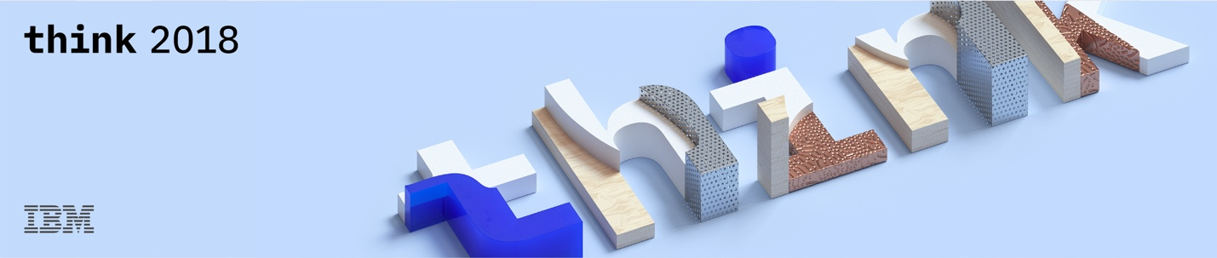

**Lab Center – Hands-on Lab**

**Session 9605**

**Session Title OK Google! Book me a movie ticket with IBM Mobile and IBM Cloud**

Srihari Kulkarni, IBM, skulkarni@in.ibm.com

Norton Stanley, IBM, nostanle@in.ibm.com

**Table of Contents**

**Disclaimer** 3

**Pre-requisites** 6

**Introduction** 6

**Getting the code** 6

**Define the dialog flow** 7

1. Login to Dialogflow 7

2. Create an Agent 8

3. Create the intents 8

1. Create Entities 9

**Configure Firebase for enabling push notifications** 9

1. Add firebase to your app 10

2. Get your push credentials 11

**Setup Push Notifications on IBM Cloud** 12

1. Create a Push notifications instance on IBM Cloud 12

4. Configure your instance 12

1. Customize the code for your Node.js app 13

2. Publish your app to IBM Cloud 13

**We Value Your Feedback!** 17

# **Disclaimer**

IBM’s statements regarding its plans, directions, and intent are subject to change or withdrawal without notice at IBM’s sole discretion. Information regarding potential future products is intended to outline our general product direction and it should not be relied on in making a purchasing decision.

The information mentioned regarding potential future products is not a commitment, promise, or legal obligation to deliver any material, code or functionality. Information about potential future products may not be incorporated into any contract.

The development, release, and timing of any future features or functionality described for our products remains at our sole discretion I/O configuration, the storage configuration, and the workload processed. Therefore, no assurance can be given that an individual user will achieve results like those stated here.

Information in these presentations (including information relating to products that have not yet been announced by IBM) has been reviewed for accuracy as of the date of initial publication and could include unintentional technical or typographical errors. IBM shall have no responsibility to update this information. **This document is distributed “as is” without any warranty, either express or implied. In no event, shall IBM be liable for any damage arising from the use of this information, including but not limited to, loss of data, business interruption, loss of profit or loss of opportunity.** IBM products and services are warranted per the terms and conditions of the agreements under which they are provided.

IBM products are manufactured from new parts or new and used parts.   
In some cases, a product may not be new and may have been previously installed. Regardless, our warranty terms apply.”

**Any statements regarding IBM's future direction, intent or product plans are subject to change or withdrawal without notice.**

Performance data contained herein was generally obtained in controlled, isolated environments.  Customer examples are presented as illustrations of how those  
customers have used IBM products and the results they may have achieved. Actual performance, cost, savings or other results in other operating environments may vary.

References in this document to IBM products, programs, or services does not imply that IBM intends to make such products, programs or services available in all countries in which IBM operates or does business.

Workshops, sessions and associated materials may have been prepared by independent session speakers, and do not necessarily reflect the views of IBM. All materials and discussions are provided for informational purposes only, and are neither intended to, nor shall constitute legal or other guidance or advice to any individual participant or their specific situation.

It is the customer’s responsibility to insure its own compliance with legal requirements and to obtain advice of competent legal counsel as to the identification and interpretation of any relevant laws and regulatory requirements that may affect the customer’s business and any actions the customer may need to take to comply with such laws. IBM does not provide legal advice or represent or warrant that its services or products will ensure that the customer follows any law.

Information concerning non-IBM products was obtained from the suppliers of those products, their published announcements or other publicly available sources. IBM has not tested those products about this publication and cannot confirm the accuracy of performance, compatibility or any other claims related to non-IBM products. Questions on the capabilities of non-IBM products should be addressed to the suppliers of those products. IBM does not warrant the quality of any third-party products, or the ability of any such third-party products to interoperate with IBM’s products. **IBM expressly disclaims all warranties, expressed or implied, including but not limited to, the implied warranties of merchantability and fitness for a purpose.**

The provision of the information contained herein is not intended to, and does not, grant any right or license under any IBM patents, copyrights, trademarks or other intellectual property right.

IBM, the IBM logo, ibm.com and [names of other referenced IBM products and services used in the presentation] are trademarks of International Business Machines Corporation, registered in many jurisdictions worldwide. Other product and service names might be trademarks of IBM or other companies. A current list of IBM trademarks is available on the Web at "Copyright and trademark information" at[: www.ibm.com/legal/copytrade.shtml](http://www.ibm.com/legal/copytrade.shtml).

© 2018 International Business Machines Corporation. No part of this document may be reproduced or transmitted in any form without written permission from IBM.

**U.S. Government Users Restricted Rights — use, duplication or disclosure restricted by GSA ADP Schedule Contract with IBM.**

# **Pre-requisites**

To do this lab, you will need the following

1. An IBM Cloud account.

If you do not have one, create one at <http://bit.ly/bmregistration>

OR

Ask your lab proctor for one of the instructor IDs

1. A Google Developer account <https://console.developers.google.com/projectselector/apis/dashboard?pli=1>

# **Introduction**

In this lab, you will build a conversation model for a Google Home voice assistant which simulates booking a movie ticket by in. You will also build a companion mobile app which you will use to authenticate your transaction and receive the much awaited movie ticket.

In this lab, you will write a Node.js app and host in on the IBM Cloud. This Node app will perform the backend processing and return the user with a One Time Password (OTP) to the user’s mobile device using the IBM Push Notifications service on IBM Cloud. When the transaction is completed, the node app will deliver a ticket in the form of a QR code to the end user as a push notification.

# **Getting the code**

Open a Terminal window and type the following commands

**cd /work**

**mkdir lab9605**

**cd lab9605**

**git clone** [**https://github.com/Think18/Lab9605.git**](https://github.com/Think18/Lab9605.git)

# **Define the dialog flow**

In this step, you will define the conversation pattern for your Google Home device on Dialogflow

This flow will be configured to call a webhook for backend integration which is running on IBM Cloud.

## Login to Dialogflow

1. Visit <https://dialogflow.com> in a browser
2. Click on Go to Console
3. Sign in with your Google ID into Dialogflow.

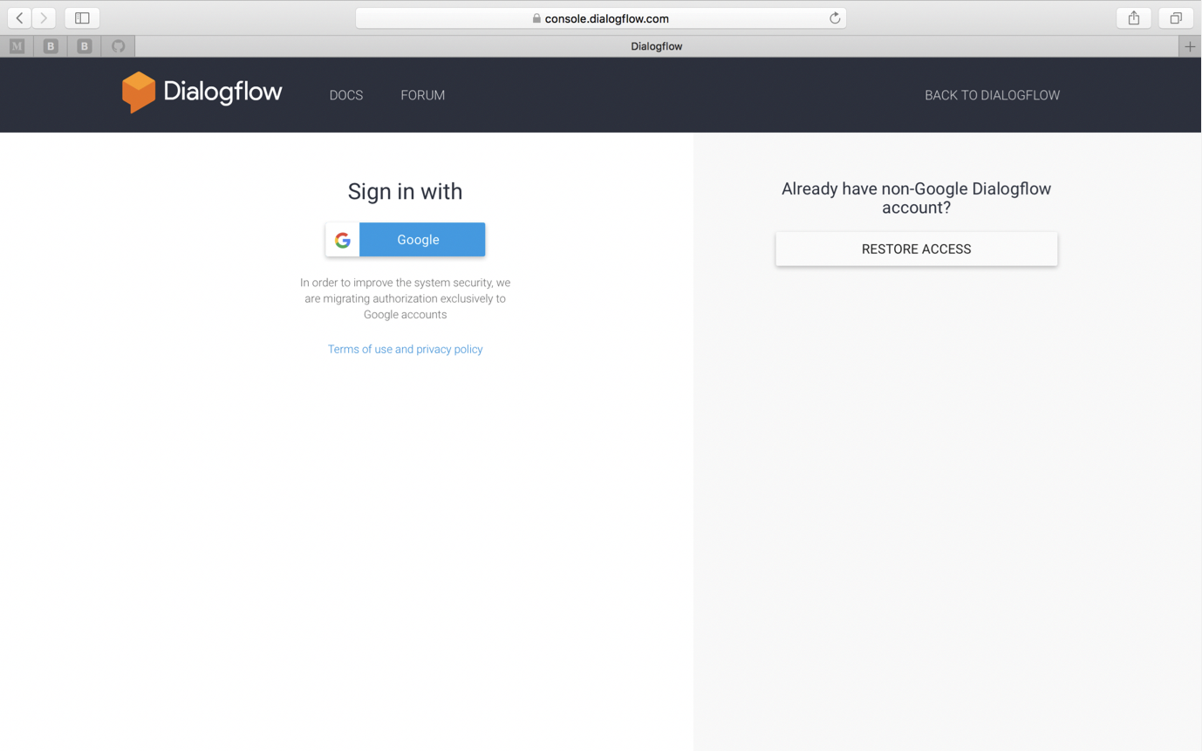

You should now see the following screen

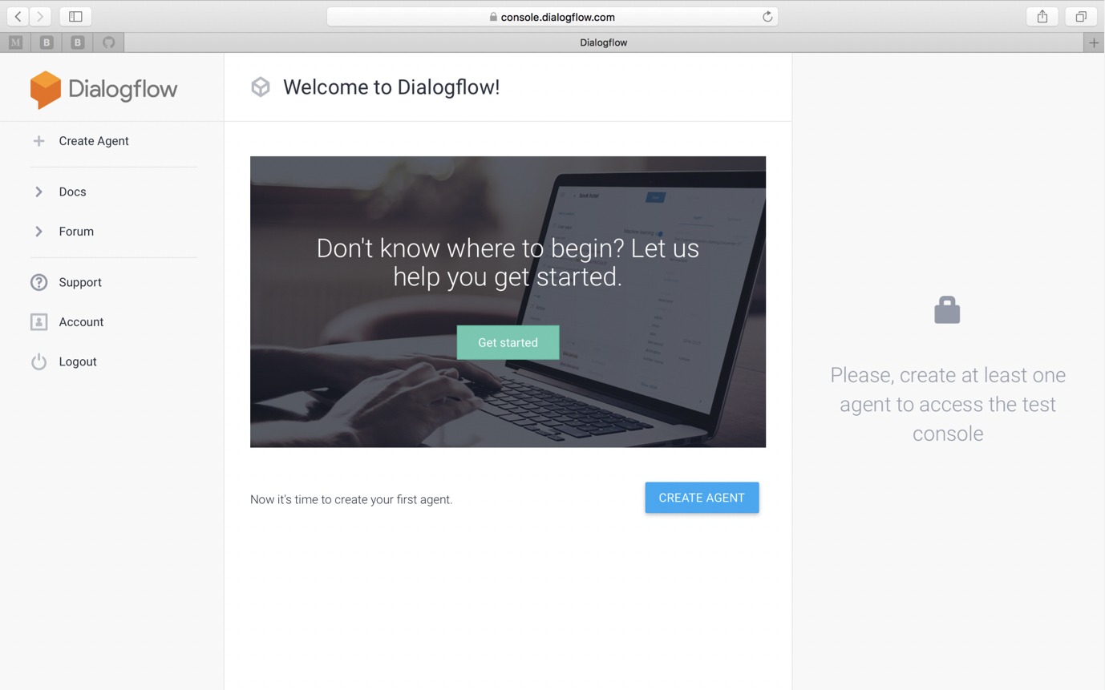

## Create an Agent

1. Click on Create Agent in the left panel.
2. In the following screen type “MyBoxOffice” as the name of the agent and click “Create”

The next step is to define an Intent. Intents define the action to be performed on each query posted by the end user.

## Create the intents

1. Click on “Intents” in the left panel. In the following screen, click on the overflow icon and then choose “Upload Intent”

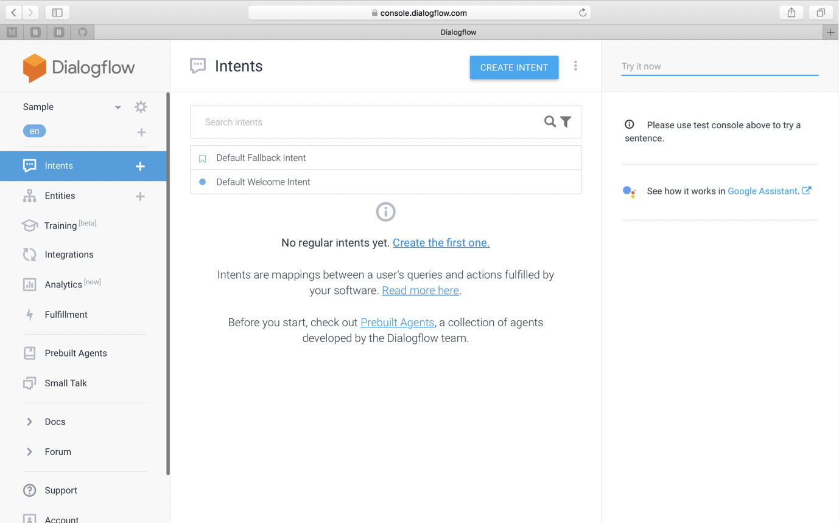

1. Navigate to /work/lab9605/Lab9605/Intents folder and choose OTP_Intent.json

Similarly, repeat the upload for Ticket.json

## Create Entities

1. Click on Entities on the left panel.
2. Similar to Intents, click on the overflow icon.
3. Choose Upload Entity.
4. Navigate to the /work/lab9605/Lab9605/Entities folder and upload movie_name.json

You have now successfully setup the dialog flow for your Google Home app.

# **Configure Firebase for enabling push notifications**

You will have to configure Firebase to deliver push notifications to your mobile app. Firebase is necessary to deliver push notifications to Android devices.

## Add firebase to your app

1. Open <https://console.firebase.google.com/> in a browser

You will find the Dialog flow app that you created earlier here.

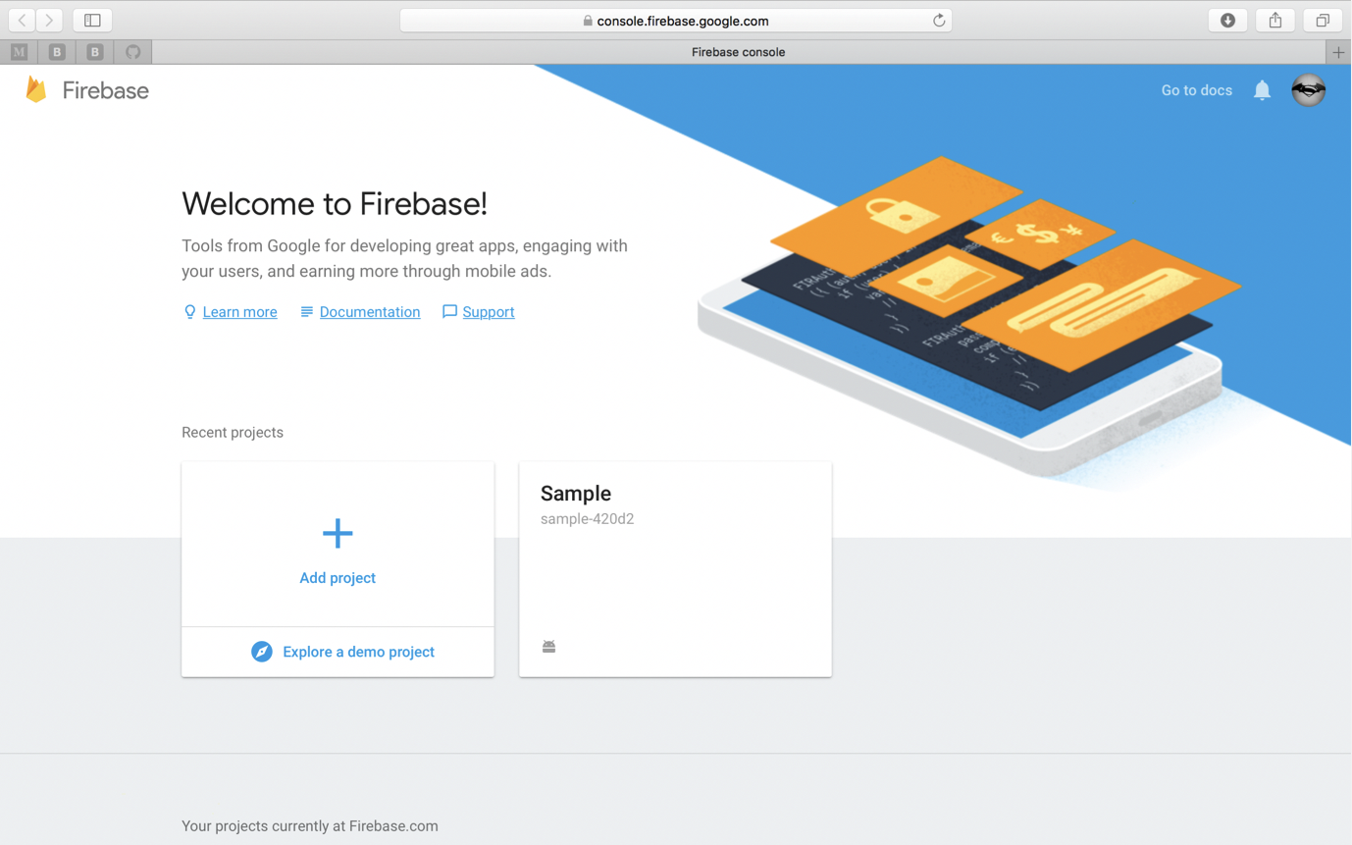

1. Click on your app’s name
2. In the following screen, choose “Add Firebase to your Android app”

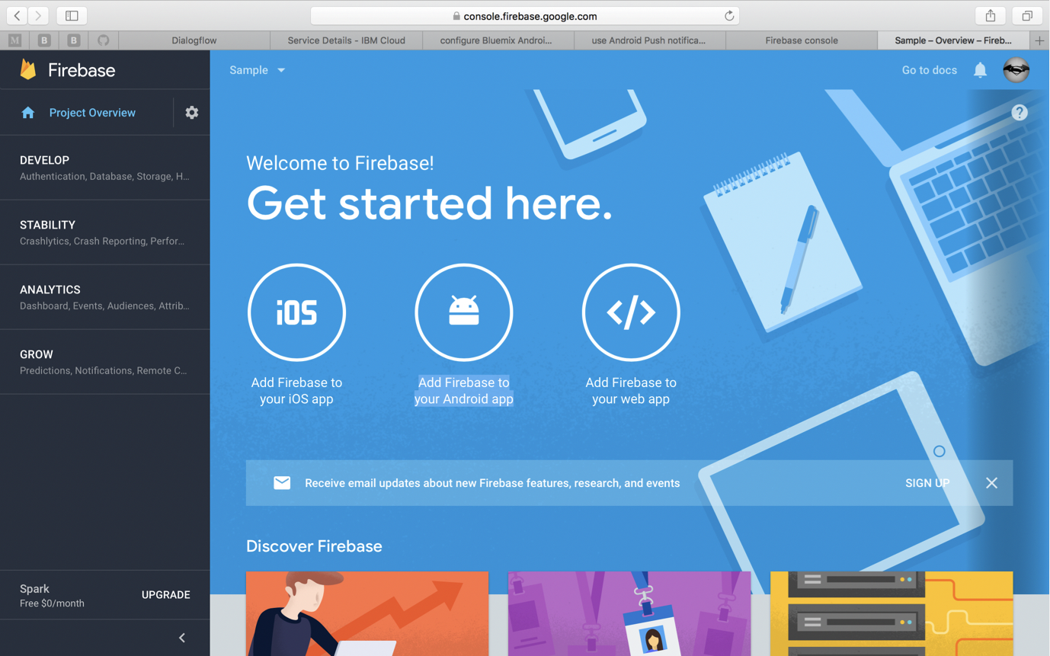

## Get your push credentials

1. In the following screen, register your app by providing com.ibm.hellopush as the package name
2. Download the google-services.json file and complete the wizard.
3. Copy the google-services.json file to the following path /work/lab9605/Lab9605/ myboxoffice-android-master/myboxofficeapp/app
4. If the file already exists, replace it.
5. In the Firebase console, click on the Settings icon in the left panel.
6. Navigate to the “Cloud Messaging” tab.
7. Here, you will find the credentials for your app to be able to access Google Firebase notifications.

You will need the server key and the sender ID among these.

Copy these into a text file for future use.

This completes the setup required on Firebase for your Android app to receive push notifications.

Similary, for an iOS app, you will have to follow the instructions provided on the [Apple Developer page](https://developer.apple.com/notifications/)

# **Setup Push Notifications on IBM Cloud**

## Create a Push notifications instance on IBM Cloud

1. Go to the Mobile Developer Dashboard on IBM Cloud (<https://console.bluemix.net/developer/mobile/dashboard> ) an login with your IBM Cloud credentials (Bluemix credentials). If you do not have one, ask the instructions for a set of credentials you can use
2. Go to the Catalog and search for Push Notifications in the catalog.
3. Create an instance of the Push Notifications service

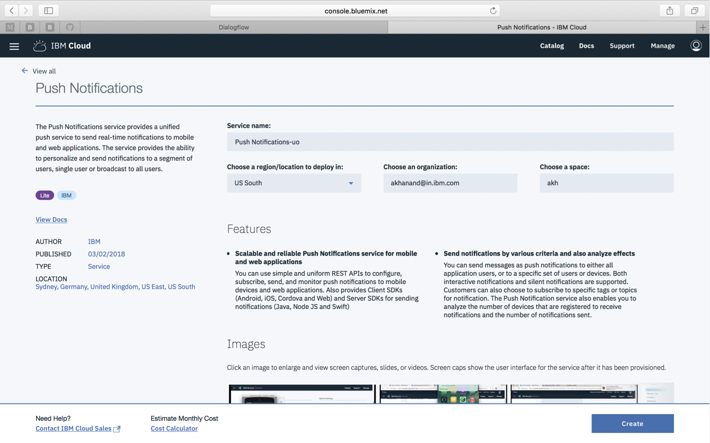

## Configure your instance

1. Click on Manage > Configure
2. Copy & paste the server key and project ID under GCM/FCM credentials section and click Save.
3. Click on Mobile Options (in the top right corner) to get the application credentials for your mobile app
4. Copy the App GUID and Client secret (not App secret) into a text file for later use.

**Setup the backend Node.js service on IBM Cloud**

## Customize the code for your Node.js app

1. Navigate to the folder /work/lab9605/Lab9605/movie-ticket-node

This folder contains the source for the Node.js app that will deliver a One Time Password and the ticket to the mobile app.

1. Open the file server.js in an editor.

Look for the text “AppGuid” and “App secret” and replace these string with actual values previously copied.

## Publish your app to IBM Cloud

1. Open a terminal window and type the following commands

These will install all required dependencies

cd /work/lab9605/Lab9605/movie-ticket-node

npm install

npm install ibm-push-notifications –save

1. Login to IBM Cloud from the command line

bx login

# Provide your IBM cloud credentials

bx api api.ng.bluemix.net

bx cf push

This step will push your node app to your account on IBM Cloud.

1. Go back to the IBM Cloud Catalog (<https://console.bluemix.net/catalog/> )

Search for Cloudant and click on Create to create an instance of Cloudant NoSQL DB

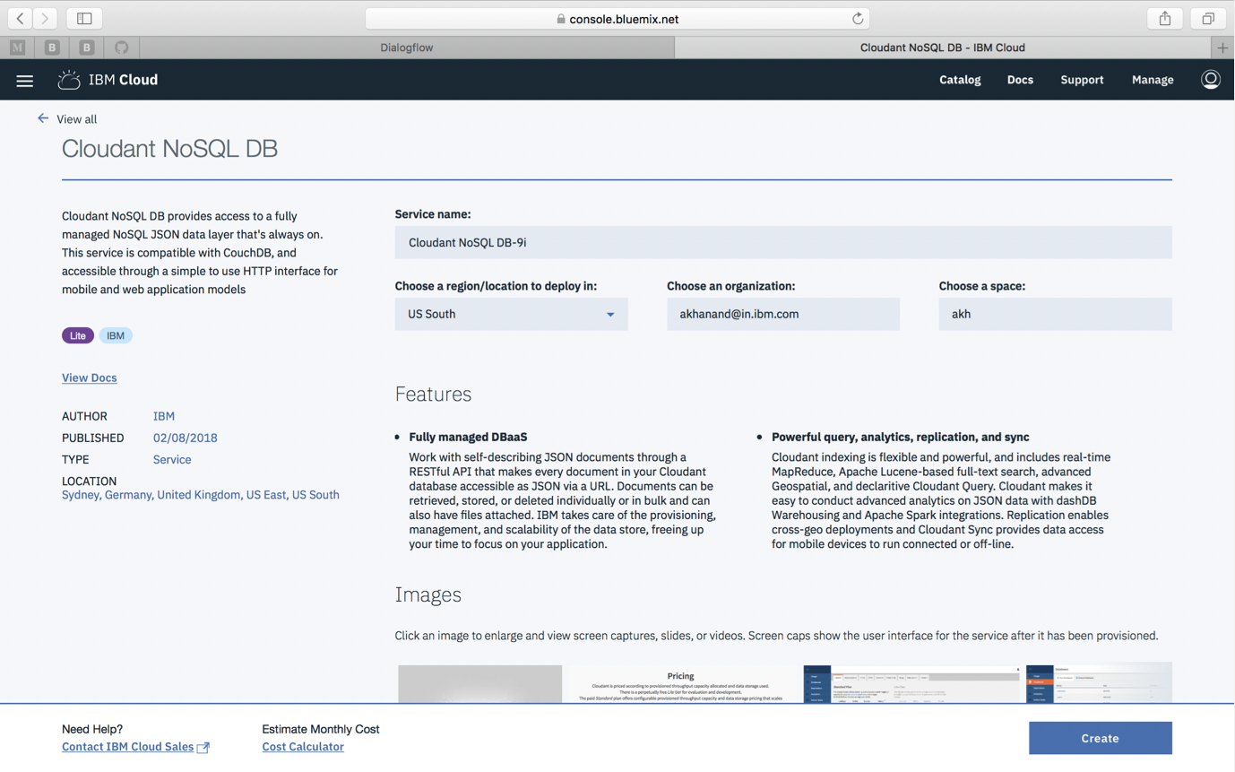

1. Click on Dashboard from the hamburger menu on the left.

Click on getstartednode or the node app you have deployed

Click Connections

Click Create Connection

Click Connect next to the Cloudant service you just created.

1. Click on the “Routes” dropdown at the top of your screen. This will provide you with the external route your node app is configured with. Copy this route URL.
2. Go back to the Dialogflow configuration and go to the Fulfillment section

Turn on the Webhook fulfillment option

Enter the route (from step 7) here and append with /api/visitors

For example: <https://yoururl.mybluemix.net/api/visitors>

Click Save

**Get your movie ticket mobile app running**

1. In a terminal window type the following commands to fire up Android Studio.

This will be your IDE for building and running your app.

cd /work/android-studio/bin

./studio.sh

1. Click on “Open an existing Android Studio project”

Navigate to the folder /work/lab9605/Lab9605/myboxoffice-android-master/myboxofficeapp

1. In the Android Studio IDE, locate the file called MainActivity,java

In this file, locate the push.Initialize() call and replace the strings “<APP_GUID> and “CLIENT_SECRET” with the App GUID and Client secret from the previous step.

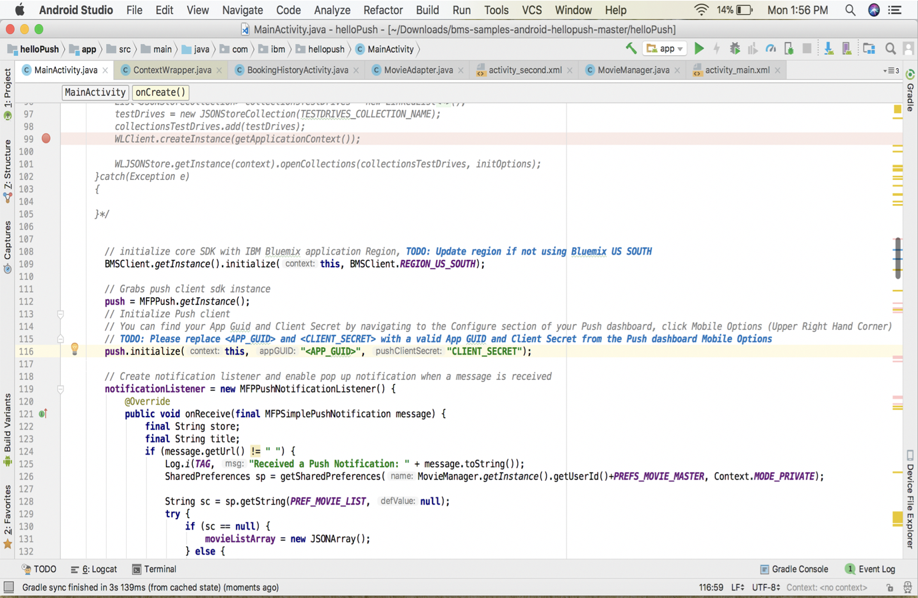

1. Build and run your mobile app from Android Studio
2. Provide any user id of your choice and login

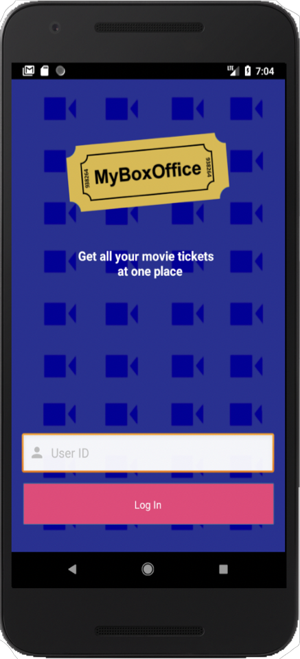

1. Dialogflow provides a simulator for Google Home. Click on Google Assistant in the right panel in Dialogflow console
2. Start by talking to your Google assistant

“Talk to MyBoxOffice”

Enter the name of the movie

Then enter the number of tickets you need and the date

The OTP will be delivered to your moble app via a push notification.

Provide the OTP in the conversation

After your ticket is successfully booked, you will receive a ticket with a QR code in your app.

# **We Value Your Feedback!**

* Don’t forget to submit your Think 2018 session and speaker feedback! Your feedback is very important to us – we use it to continually improve the conference.
* Access the Think 2018 agenda tool to quickly submit your surveys from your smartphone, laptop or conference kiosk.